Malala Fund’s submission:
Impact of the COVID-19 pandemic on the realization of the equal enjoyment of the right to education by every girl

Introduction
Even before the COVID-19 pandemic disrupted education systems across the world, 263 million children were already out of school. We have seen prolonged and repeated school closures along with the economic and health strains brought on by the pandemic. This is likely to cause many children - particularly girls - to drop out of the education system permanently.
During crises girls and young women are the first to be removed from school, the least likely to learn from home and the last to return to the classroom. Malala Fund’s calculations - based on insights from the 2014-5 Ebola epidemic and the 2008 global financial crisis - estimates that 20 million more secondary school-aged girls could be out of school after the crisis has passed.
To understand the impact of the COVID-19 pandemic and ensuing school closures on re-enrollment for girls and boys, Malala Fund, with our Education Champions Networks, commissioned a series of rapid surveys in Ethiopia, India, Nigeria, and Pakistan. These surveys elicited responses from both parents and children, with children self-reporting their likelihood of going back to school and other education and learning experiences during the pandemic.
Like most other countries around the world, Ethiopia, India, Nigeria, and Pakistan closed their schools in March 2020. It’s important to note that during the survey period, Nigeria and Pakistan had started a phased reopening of schools, while schools remained closed in Ethiopia and India. Since then many schools have reopened. However, the process of reopening schools has not been linear. As new strains emerge and cases surge governments have responded by repeatedly shutting down schools. In January 2022, just four months after ending a one and half year school closure imposed due to COVID-19, Bangladesh shut schools once again amid Omicron surges. The findings from these rapid surveys, therefore, provide a snapshot of the impacts of the COVID-19 pandemic on education during the peak of the pandemic and more research is underway to understand the long-term challenges two years on.

Challenges and barriers for girls in the context of the COVID-19 pandemic
i. Impact by level of education
Children in lower grades face a higher risk of dropout
The majority of students that we surveyed — both girls and boys — wanted to learn during lockdown and expressed their hopes to return to school. The likelihood of re-enrollment, however, varies by grade of the child. Of the children we surveyed, those in lower grades in Ethiopia, Nigeria, and Pakistan were more likely to report that they would not return to school once they reopened. [See Annex 1]
In Pakistan, children in lower grades (below grade 5) were much more likely to report that they would not return to school than children in higher grades. A similar pattern holds in Ethiopia. In Nigeria, we observe a spike in likelihood of not returning to school in grade 5, a year before a high-stakes exam determining transition to secondary schools, and then again in the first year of secondary. In India, two peaks are visible: children nearing lower primary completion and those nearing secondary completion seem most at risk of not returning to school. Understanding which grades are most at risk of seeing high dropouts has implications for how we target and design re-enrollment efforts as schools begin to reopen.
ii. Availability and accessibility
Availability and access to distance learning has implications for children’s preparedness as they head back to school and how schools implement remediation measures to mitigate learning loss.
Low access to technology
Most students surveyed (e.g. 90% of boys and girls in Ethiopia) said that they would be happy to receive learning material during lockdown. Our research, however, found that governments’ distance learning programmes were not reaching students. When children were asked about how they spend their day at home while schools are closed, close to 40% reported not engaging with any type of learning activity at home, such as studying offline or using TV or radio for distance learning. Television and radio lessons were the favoured approach to distance learning in all the countries. However, just one-fifth of those children engaged in learning activities report that they used a television, and only 5% mention using a radio. In Nigeria, radio use was much higher (22%) compared to the other countries where it was less than 3%. Among those surveyed very few students were using ed tech for distance learning. In Pakistan less than 1% of students reported using ed tech for distance learning.
The availability of a TV or radio in the household did not automatically translate into access to distance learning. In Pakistan the majority of respondents (67%) said they had a TV at home and around one-third had radio whereas only 20% of girls and boys were spending time on educational TV and just 2% on educational radio. Similar results were found in Ethiopia where most households surveyed had access to TV and almost half reported having a radio yet the uptake of EduTV and EduRadio was very low at 11% and 2% respectively.
Lack of alternatives to tech-based learning
Our survey in Nigeria found only nine out of over 1,300 households reported having received any education related materials directly from schools or the education department. In both Ethiopia and Nigeria, just 3% of households received support of any kind from schools, teachers or any representative of the education department; the support they did receive was mostly in the form of midday meals or health-related materials, such as soap or masks. Meanwhile, in Pakistan, the majority of students said that they wanted to receive printed educational materials (such as postcards or books).
Children from households experiencing a cash crunch are at a higher risk of not returning to school
Overall, 74% of households reported experiencing a cash crunch at the time of the survey, with only 40% of such households receiving help from the government or NGOs - 15% from government only, 11% from NGOs only, and 14% from both. Among households reporting a cash crunch, 6% of children report not being sure if they are going back to school [See Annex 2]. Across all four countries, children from households experiencing a cash crunch were at a higher risk of not returning to school. In Pakistan, where almost 60% of households report facing financial difficulties, children from such households were almost twice as likely to report that they would not return to school compared to children from households more protected from financial shocks.
A similar pattern emerges when looking at households facing food insecurity although the differences were smaller. Children from food insecure households reported a lower likelihood of returning to school in India, Nigeria, and Ethiopia (with no discernible difference in Pakistan) compared to households that were food secure. Overall, 45% of families reported experiencing food insecurity at the time of the survey and only 32% of such households reported receiving help from the government or NGOs.
Additionally, there were huge disparities in access to learning at home between households experiencing a cash crunch and those that were not, particularly in Nigeria and Pakistan. Overall, 42% of children from households facing financial difficulties reported not engaging with any type of learning versus 34% of children from households that were secure from economic shocks.
This may explain why school fees and the need to work (along with COVID-19 fears) were the most commonly cited reasons for not going back to school in all four countries [See Annex 3]. Analysis of responses from India suggests that more boys than girls were going to fee-charging private schools and may face heightened risk of dropping out due to the income losses faced by families. As schools begin to reopen families’ concerns about the ability to pay school-related fees made returning to school uncertain for some students.
iii. Acceptability
Even where learning materials were available the majority of girls and boys across the countries estimated that they spent under two hours a day studying compared with the approximately five to six hours per day that they spent on lessons at school. There are a number of potential reasons that students may spend markedly less time studying during lockdown than would be expected in a typical school day, some of them related to gender norms.

Acceptability of girls’ accessing online technology
​​While distance learning efforts, such at the Learn at Home Programme in Nigeria, were theoretically available to many students via the internet, TV and radio, both technological and social norm barriers constrain access to technology-dependent learning options. While more households have access to TV and radio, relying on broadcasting as a learning tool depends on strong infrastructure and uninterrupted electricity.
Although most of the households surveyed reported owning at least one phone (Nigeria), the majority of respondents said that they only intermittently have access to smartphones. For girls this may be partly due to resistance by parents. According to a study in the North of Nigeria, 61% of fathers discourage their daughters’ use of the internet. In addition, students who were able to use smartphones at home reported not always being able to afford the data required. Even for students with internet access, service interruptions presented challenges. Similarly we found stark differences between boys (24%) and girls (10%) access to distance learning offered via television.
In Pakistan where access to smartphones was fairly high (60%), around three-quarters of those with access reported only being able to afford data intermittently. Girls were almost 40% more likely than boys to say that they never had access to a mobile device and their most frequently cited reason for not accessing a phone was being afraid to ask.
Insufficient support at home, especially for girls
Across countries respondents said they rely on their immediate family to support them with learning at home. While welcome, this has the potential to reproduce educational inequalities in two ways. First, reliance on family risks reproducing education inequalities from generation to generation, given low levels of parental education in some regions. Second, the survey found stark differences in the support received by boys and girls. The Nigeria survey found that while mothers supported sons and daughters almost equally, fathers were 36% more likely to assist their sons’ learning than their daughters’.
Across the countries less than 15% of girls overall reported having access to a private tutor with a slightly higher proportion of boys (17%) reporting the same. However, in some countries the difference between boys and girls was quite stark. While access to tutors was low in general in Ethiopia, girls were 50% less likely than boys to report that they received learning assistance from a personal tutor. In Nigeria, boys were more than twice as likely to have access to a private tutor during the pandemic, while one out of four girls, or 50% more girls than boys said they received no learning assistance of any kind at home.
Gendered domestic burdens
There were greater domestic burdens placed on girls compared to boys during the period of school closures. Across the surveyed countries we found that a larger proportion of girls than boys spent time doing chores and care work and fewer girls reported spending time on leisure activities. In Pakistan, for example, girls spent 40% of this time on chores compared to 11% among boys, while they only spent 19% of their time on play compared to 44% among boys. Existing evidence suggests that girls were likely to spend more time doing chores and caring for siblings, which took away from time spent on school work—in our sample 63% of girls report doing household chores compared to 26% of boys. Despite these additional burdens, however, girls surveyed still found time to study. This demonstrates a strong resilience and appetite for education despite the challenges they faced from the pandemic, poverty and social norms.
iv. Adaptability
In governments’ education responses, it appears that speed, rather than equity in access and outcomes, was the priority in bringing blanket remote learning strategies to scale. Initial COVID-19 responses appear to have been developed with little gender analysis and attention to intersecting inequalities and inclusive approaches.

Concrete measures taken to respond to challenges and barriers faced by girls
UNESCO’s report “When schools shut: Gendered impacts of COVID-19 school closures” provides a useful assessment of the world’s response to mitigating the gendered impacts of COVID-19 school closures. However, more is needed to document successful practices, including those that are equity-focused and designed to leave no one behind, with context-specific consideration to intersecting and exacerbating inequalities.

Gender and remote learning
Less than half of countries in the most recent UNESCO, UNICEF, World Bank and OECD survey of national education responses to COVID-19 reported taking one or more measures to specifically support girls’ education during the pandemic, such as financial support, improved access to infrastructure, provision of subsidized devices, tailored learning materials, and flexible and self-paced platforms. Forty-one percent of countries reportedly deployed no special measures to support girls’ education.

Digital divide - Guidance is available for overcoming the digital gender divide to reduce inequality in remote learning. Remote Learning Modalities to Reach All Children and Youth During School Closures provides guidance and recommendations ‘focusing on low- and no-tech modalities to reach the most marginalized’ learners. In Ethiopia, ChildHope UK and the Organisation for Child Development and Transformation changed its in-person approaches to provide hard-copy learning packs. The guidance also stresses the importance of interventions that encourage parents to allow girl learners access to technology available at home to continue studying.

Gender and return to school

Female teachers - In some contexts, due to social, cultural and gender norms, parents will not allow their daughters to be taught by a male teacher. The placement of a woman teacher, therefore, can have an immediate impact on girls' access to education. While most countries provided teachers with some form of support, there was limited evidence of efforts to support female teachers who were likely to have the added burden of caring for children and sick relatives, which increases their chances of leaving the profession altogether. There was also little evidence to help teachers to recognise the unique challenges learners may experience as a result of gender expectations, restrictions and risks.

Cash transfers - cash transfers or the elimination of school-related fees to mitigate financial burdens has been a promising approach applied during COVID-19 school closures to ensure girls’ return to school. These measures have been successful in other crises in mitigating financial stress that may be the root cause of lack of engagement in remote education or a failure to return to school.

Auto-promotion - One strategy rolled out by the government of Bangladesh was auto-promotion – or advancing all learners to the next grade level – across all grade levels to mitigate the demoralizing impact of losing a year of progress. While this can be appropriate for some learners, it may be problematic for others when they return to school. Interviews with key informants suggested it might have particularly negative side effects for girls if they were unable to continue their studies remotely at home, and auto-promotion to the next level might lead to discouragement upon re-entry if they were to find the material too challenging.

Trace, Track, Talk, reTurn - Community and family engagement were common approaches to better understand learners’ needs, deliver resources and information, as well as encourage their return to school. Under the school re-entry programme, the Kenyan Ministry of Education is implementing the 4Ts – ‘Trace, Track, Talk and reTurn’ – a back-to-school campaign to promote school re-entry for learners who dropped out for various reasons including COVID-19–related factors. As of July 2021, the programme reached 1,424 out-of-school girls, of whom 84% have returned to school. Of these, over 92% were pregnant, parenting or married.

Annex
1. Percent of children reporting that they are unlikely to return to school is particularly high in lower grades in Ethiopia, Nigeria, and Pakistan
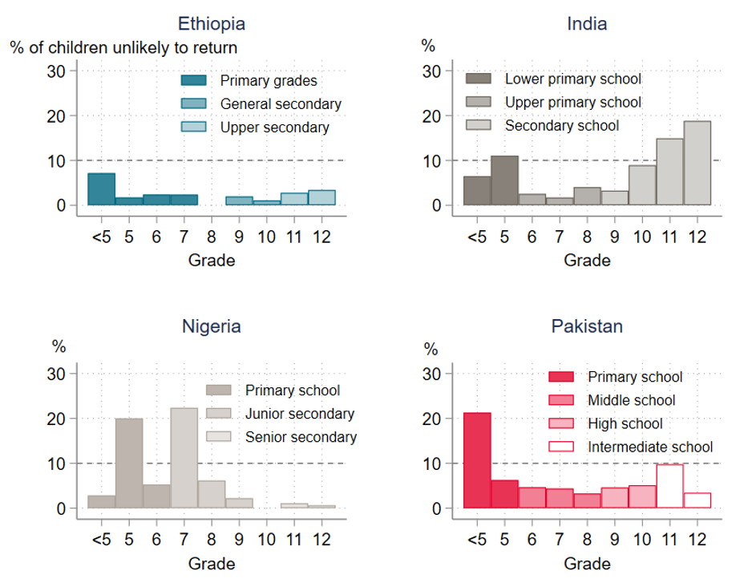

2. Percent of families facing a cash crunch vs percent of children unlikely to return to school
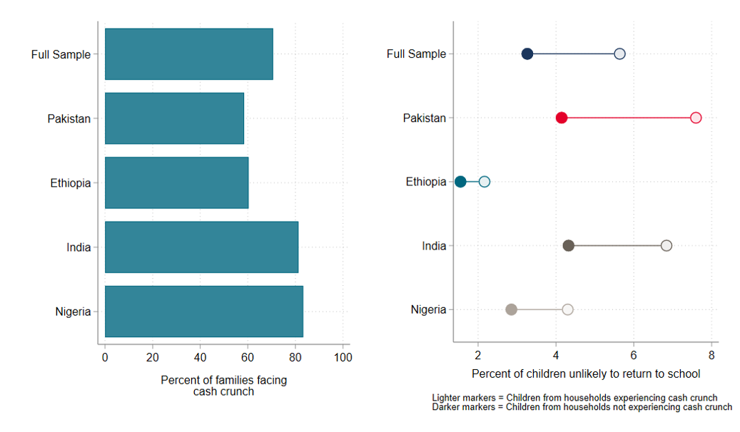
3. Percent of children unlikely to go back to school and reasons why
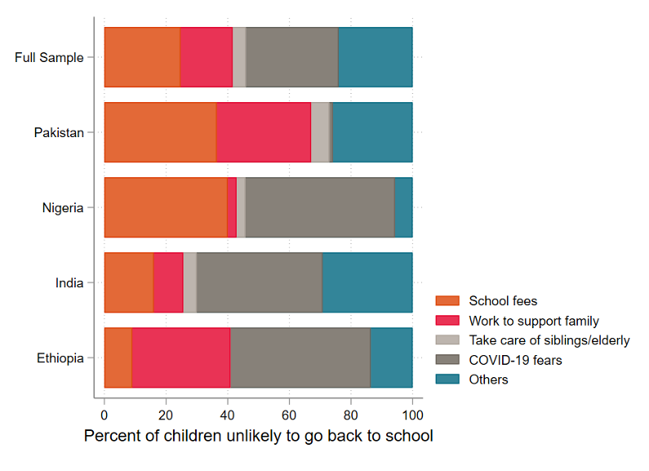

UN News. 2016. New UN study estimates 263 million children and youth now out of school.https://news.un.org/en/story/2016/07/534442-new-un-study-estimates-263-million-children-and-youth-now-out-school
2020. ETHIOPIA AND COVID-19 IN GIRLS’ EDUCATION. [ebook] Malala Fund. https://assets.ctfassets.net/0oan5gk9rgbh/4870tL2O6Zg29oy8AMkqJ7/1ca915cd268870dc13b0ad91e282fedb/Ethiopia_Report_08.pdf
2020. Girls' education and COVID-19 in India. [ebook] Malala Fund. https://assets.ctfassets.net/0oan5gk9rgbh/575SyyaQ9T5cX0b2LuK2BA/eacd2eabf2223b3095abe9f0eb916d15/India_Report_website.pdf
2020. Girls' education and COVID-19 in Nigeria. [ebook] Malala Fund. https://assets.ctfassets.net/0oan5gk9rgbh/4SoYwXYgLMiIWPqvdikb0W/4d2ebc3b8289b2beaae33867d79af698/Nigeria_Report_22.pdf
2020. Girls' education and COVID-19 in Pakistan. [ebook] Malala Fund. https://assets.ctfassets.net/0oan5gk9rgbh/5NYWB1DMSyo5a8VaQfOg7t/0386baa8673eecf0c4589be9f5c1be73/Pakistan_Report_16_MF.pdf
Ruma Paul, 2022. Bangladesh shuts schools as coronavirus cases surge. [online] https://www.reuters.com/world/asia-pacific/bangladesh-shuts-schools-coronavirus-cases-surge-2022-01-21/
Malala Fund | Newsroom. 2020. Malala Fund releases report on girls’ education and COVID-19 | Malala Fund Newsroom. https://malala.org/newsroom/archive/malala-fund-releases-report-girls-education-covid-19
Center for Information Technology and Development (2016) Overcoming gender-based digital exclusion in northern Nigeria: A strategy document. https://www.apc.org/en/pubs/overcoming-gender-based-digital-exclusion-northern
BBC (2020) Article: How internet access is improving in Nigeria. http://www.bbc.co.uk/news/business-51377955
Akmal, M., Fry, L., Ghatak, N., Hares, S., Jha, J., Nyamweya, N. and Minardi, A., 2020. Who Is Going Back to School? A Four-Country Rapid Survey in Ethiopia, India, Nigeria, and Pakistan. [online] Center For Global Development.https://www.cgdev.org/blog/who-going-back-school-four-country-rapid-survey-ethiopia-india-nigeria-and-pakistan
However, since most children said they are going back to school, the sample size for this question is very low.
Akmal, M., Fry, L., Ghatak, N., Hares, S., Jha, J., Nyamweya, N. and Minardi, A., 2020. Who Is Going Back to School? A Four-Country Rapid Survey in Ethiopia, India, Nigeria, and Pakistan. [online] Center For Global Development.https://www.cgdev.org/blog/who-going-back-school-four-country-rapid-survey-ethiopia-india-nigeria-and-pakistan
Akmal, M., Fry, L., Ghatak, N., Hares, S., Jha, J., Nyamweya, N. and Minardi, A., 2020. Who Is Going Back to School? A Four-Country Rapid Survey in Ethiopia, India, Nigeria, and Pakistan. [online] Center For Global Development.https://www.cgdev.org/blog/who-going-back-school-four-country-rapid-survey-ethiopia-india-nigeria-and-pakistan
Ibid.
2020. Girls' education and COVID-19 in Nigeria. [ebook] Malala Fund. https://assets.ctfassets.net/0oan5gk9rgbh/4SoYwXYgLMiIWPqvdikb0W/4d2ebc3b8289b2beaae33867d79af698/Nigeria_Report_22.pdf
2020. Girls' education and COVID-19 in Nigeria. [ebook] Malala Fund. https://assets.ctfassets.net/0oan5gk9rgbh/4SoYwXYgLMiIWPqvdikb0W/4d2ebc3b8289b2beaae33867d79af698/Nigeria_Report_22.pdf
2020. Girls' education and COVID-19 in Pakistan. [ebook] Malala Fund. https://assets.ctfassets.net/0oan5gk9rgbh/5NYWB1DMSyo5a8VaQfOg7t/0386baa8673eecf0c4589be9f5c1be73/Pakistan_Report_16_MF.pdf
2020. Girls' education and COVID-19 in Pakistan. [ebook] Malala Fund. https://assets.ctfassets.net/0oan5gk9rgbh/5NYWB1DMSyo5a8VaQfOg7t/0386baa8673eecf0c4589be9f5c1be73/Pakistan_Report_16_MF.pdf
Ibid.
2020. Girls' education and COVID-19 in Nigeria. [ebook] Malala Fund. https://assets.ctfassets.net/0oan5gk9rgbh/4SoYwXYgLMiIWPqvdikb0W/4d2ebc3b8289b2beaae33867d79af698/Nigeria_Report_22.pdf
Akmal, M., Fry, L., Ghatak, N., Hares, S., Jha, J., Nyamweya, N. and Minardi, A., 2020. Who Is Going Back to School? A Four-Country Rapid Survey in Ethiopia, India, Nigeria, and Pakistan. [online] Center For Global Development.https://www.cgdev.org/blog/who-going-back-school-four-country-rapid-survey-ethiopia-india-nigeria-and-pakistan
Ibid.
Ibid.
2020. ETHIOPIA AND COVID-19 IN GIRLS’ EDUCATION. [ebook] Malala Fund. https://assets.ctfassets.net/0oan5gk9rgbh/4870tL2O6Zg29oy8AMkqJ7/1ca915cd268870dc13b0ad91e282fedb/Ethiopia_Report_08.pdf
Akmal, M., Fry, L., Ghatak, N., Hares, S., Jha, J., Nyamweya, N. and Minardi, A., 2020. Who Is Going Back to School? A Four-Country Rapid Survey in Ethiopia, India, Nigeria, and Pakistan. [online] Center For Global Development. https://www.cgdev.org/blog/who-going-back-school-four-country-rapid-survey-ethiopia-india-nigeria-and-pakistan
2020. Girls' education and COVID-19 in Pakistan. [ebook] Malala Fund. https://assets.ctfassets.net/0oan5gk9rgbh/5NYWB1DMSyo5a8VaQfOg7t/0386baa8673eecf0c4589be9f5c1be73/Pakistan_Report_16_MF.pdf
Akmal, M., Fry, L., Ghatak, N., Hares, S., Jha, J., Nyamweya, N. and Minardi, A., 2020. Who Is Going Back to School? A Four-Country Rapid Survey in Ethiopia, India, Nigeria, and Pakistan. [online] Center For Global Development. Accessed 17.02.2022 https://www.cgdev.org/blog/who-going-back-school-four-country-rapid-survey-ethiopia-india-nigeria-and-pakistan
Ibid.
2020. ETHIOPIA AND COVID-19 IN GIRLS’ EDUCATION. [ebook] Malala Fund. https://assets.ctfassets.net/0oan5gk9rgbh/4870tL2O6Zg29oy8AMkqJ7/1ca915cd268870dc13b0ad91e282fedb/Ethiopia_Report_08.pdf
2020. ETHIOPIA AND COVID-19 IN GIRLS’ EDUCATION. [ebook] Malala Fund. https://assets.ctfassets.net/0oan5gk9rgbh/4870tL2O6Zg29oy8AMkqJ7/1ca915cd268870dc13b0ad91e282fedb/Ethiopia_Report_08.pdf
2020. ETHIOPIA AND COVID-19 IN GIRLS’ EDUCATION. [ebook] Malala Fund. https://assets.ctfassets.net/0oan5gk9rgbh/4870tL2O6Zg29oy8AMkqJ7/1ca915cd268870dc13b0ad91e282fedb/Ethiopia_Report_08.pdf
2021. When schools shut Gendered impacts of COVID-19 school closures. [ebook] Paris: United Nations Educational, Scientific and Cultural Organization,. :https://unesdoc.unesco.org/ark:/48223/pf0000379270/PDF/379270eng.pdf.multi
Ibid.
Ibid.
Kirk, J., 2006. The impact of women teachers on girls' education. Bangkok: UNESCO.
2021. When schools shut Gendered impacts of COVID-19 school closures. [ebook] Paris: United Nations Educational, Scientific and Cultural Organization,. :https://unesdoc.unesco.org/ark:/48223/pf0000379270/PDF/379270eng.pdf.multi
Ibid.
Gachoyo et al., 2021 and Population Council et al., 2021.
Ibid.

